

NOVAC TECHNOLOGY SOLUTIONS

User Manual

Document Version No.: 1.00

Revision History
Version No | Reason For Changes | Author | Approver
0.01 | Draft | Anurag Kumar
1.00 | Reviewed & Approved the User Manual | Anurag Kumar | NIJANTHAN PL

Table of Contents
1. Introduction 4

2. Request to add the validation for chassis number in Motor Individual 4
3 Request to add the validation for chassis number in Motor Flee 5

Introduction

As per the requirement, system should allow asterisk (*) and Hyphen (-) in the vehicle engine number & Chassis number field.
- Guidelines, circulars, instructions and directions released from time to time by Philippines Insurance council.

Motor Individual

- System should allow to enter the asterisk (*) and hyphen (-) but should not allow spaces and other special character in the vehicle engine number & chassis number field.
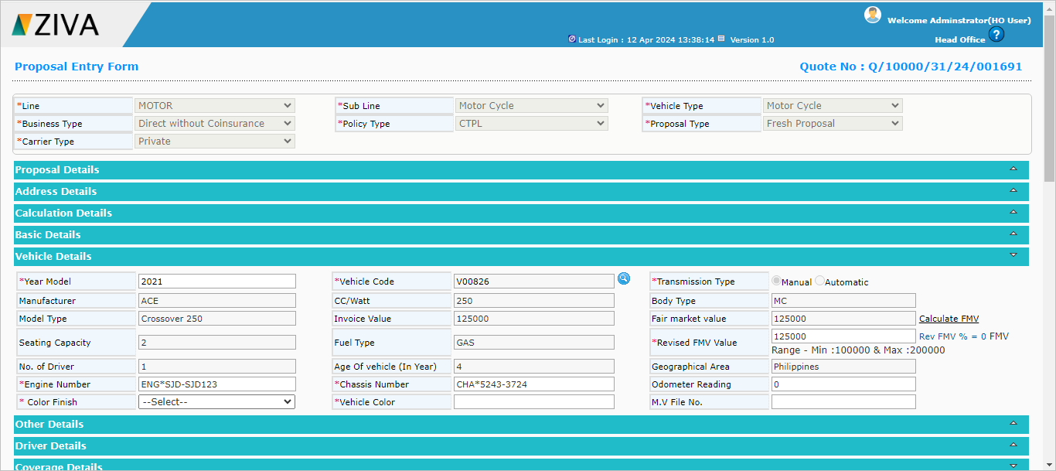

Motor Fleet
- During the motor fleet upload, system should allow to capture the asterisk (*) and hyphen (-) but should not allow spaces and other special character in the Vehicle engine & chassis number field from excel file and follow the other existing validation.
- The system should only accept alphanumeric values for the Plate Number/Conduction Sticker field and should not permit any special characters or spaces through excel file.

Click on close button to close the window.

